EXPERIMENT- 25
Perform Sharpening of Image using Gradient Masking
Aim
To write a Python code to sharpen an image using gradient masking technique in OpenCV for enhancing edge information and image details.
Code
import cv2
import numpy as np
from google.colab.patches import cv2_imshow
from google.colab import files
uploaded=files.upload()
image_path=list(uploaded.keys())[0]
image=cv2.imread(image_path)
if image is None:
print("Error: Image not found")
else:
gray=cv2.cvtColor(image,cv2.COLOR_BGR2GRAY)
blurred=cv2.GaussianBlur(gray,(5,5),0)
grad_x=cv2.Scharr(blurred,cv2.CV_64F,1,0)
grad_y=cv2.Scharr(blurred,cv2.CV_64F,0,1)
gradient=np.sqrt(grad_x**2+grad_y**2)
gradient=cv2.normalize(gradient,None,0,255,cv2.NORM_MINMAX)
gradient=np.uint8(gradient)
sharpened=cv2.addWeighted(gray,1.5,gradient,-0.5,0)
print("Original Image")
cv2_imshow(gray)
print("Gradient Sharpened Image")
cv2_imshow(sharpened)
Input & Output Image
Gradient Sharpened Image
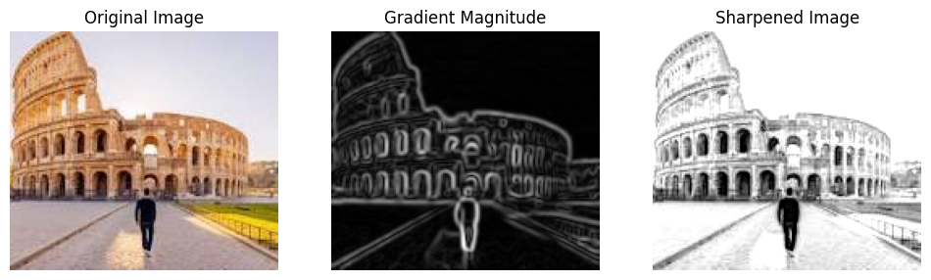
Result
Thus, the image was successfully sharpened using gradient masking technique in OpenCV.

